

**CSE326**

PROJECT REPORT ON-

**OXYGEN CLUB WEB DESIGNING**

|  |  |  |  |  |  |  |  |  |  |  |  |  |  |  |  |  |  |  |  |  |  |  |  |  |  |  |  |  |  |  |  |  |  |  |  |  |  |
| --- | --- | --- | --- | --- | --- | --- | --- | --- | --- | --- | --- | --- | --- | --- | --- | --- | --- | --- | --- | --- | --- | --- | --- | --- | --- | --- | --- | --- | --- | --- | --- | --- | --- | --- | --- | --- | --- |
| |  |  |  | | --- | --- | --- | | NAME | REGD. NO. | ROLL NO. | | SHIVANI SINGH | 12219767 | B65 | | VIPIN KUMAR | 12220492 | B71 | | SHUBH SHARMA | 12216965 | A05 |   SECTION: KOC26  SUBMITTED TO: ADHIRAJ SIR  **INDEX:**   |  |  |  | | --- | --- | --- | | S.No. | Topic | Page No. | | 1. | Introduction | 1 | | 2. | Features of Project | 2 | | 3. | Screenshots | 5-6 | | 4. | Languages Used | 7 | | 5. | Contribution of Team  Members | 8 | | 6. | Conclusion and Learning  Outcomes | 9 | | 7. | References | 10 | |  |

**Introduction**

A **sports club** or **sporting club**, sometimes an **athletics club** or **sports society** or **sports association**, is a group of people formed for the purpose of playing sports.

Sports clubs range from organisations whose members play together, and may play other similar clubs on occasion, watched mostly by family and friends, to large commercial organisations with professional players which have teams that regularly compete against those of other clubs and attract sometimes very large crowds of paying spectators. Clubs may be dedicated to a single sport or to several (**multi-sport clubs**).

So, this project is a sample web design of a Sports Club. The name of the sports club on which we made the project is named as **Oxygen Club**.

The Website contains around 4 web-pages namely **Home**, **About**, **Subscription and Contact** **Us.**

# oxygen Club

**:Website Logo**

Taking your game to the next level.

**:Website Slogan**

**Features of Project:**

1. **User-Friendly:**

A user-friendly website is something that allows your site visitor to do what they want to do with ease.

User can easily access to any section of website with a single click. **About Us** page makes the user **understand about the club** and **their vision**, **Sports page** make user **aware about the facilities provided by the club** in different sports club. We have also connected each sport with their **Wikipedia description** which makes user to **understand more about the sports** in which they are interested.

1. **Has Perfect Content:**

Have you heard of the cliché “Content is king”? That’s because original and well optimized content is what sets your website apart from your competitor. Not to mention that “content” includes your blog posts, ebooks, images, videos, and more.

Content is what **educates, informs, or entertains your site visitors**. This reiterates that they are making a smart decision to trust you and buy your products. And our website educates, informs and entertains our site visitors as we have **used hover property**, **connected our pages to Wikipedia**, there is **direct access to Sections of different clubs** and **a fine login page also**.

1. **Fine Navigation:**

The website design is **very easy to navigate,** and **the menu items are easily accessible** from any page. The viewer would always **know exactly where they are** on the website by page title and have easy access to where they would like to be. Thus, our web page has an **interactive navigation**.

1. **Eye-Catchy Visual Design:**

The features of HTML and CSS that we have used in our website like **marque**, **hover**, **page linking**, **opacity**, **slideshow**, etc. has helped us to make our website with **an eye catchy visual design.**

1. **Information Accessibility:**

Not all visitors to your website are interested in, or have the time to peruse the entire site. They may need to access only a phone number or address, or just a certain bit of info.So, for these kinds of people we have added a **Contact Us page** our navigation bar.

**Screenshots:**

1. **Home Page:**

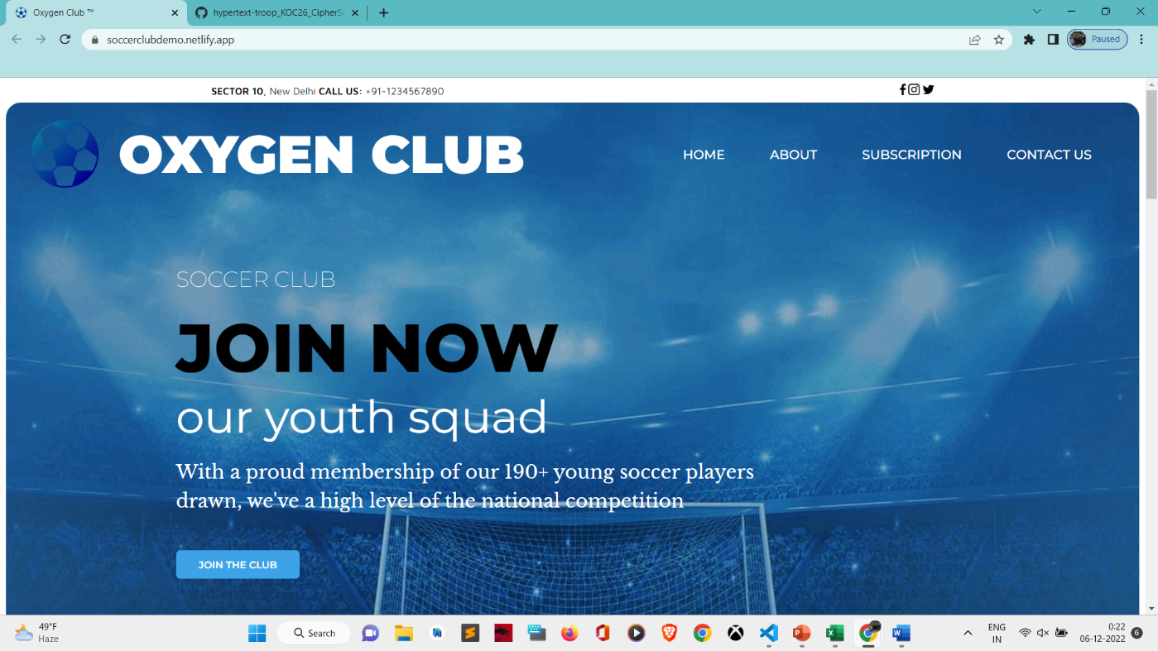

**2.About Page:**

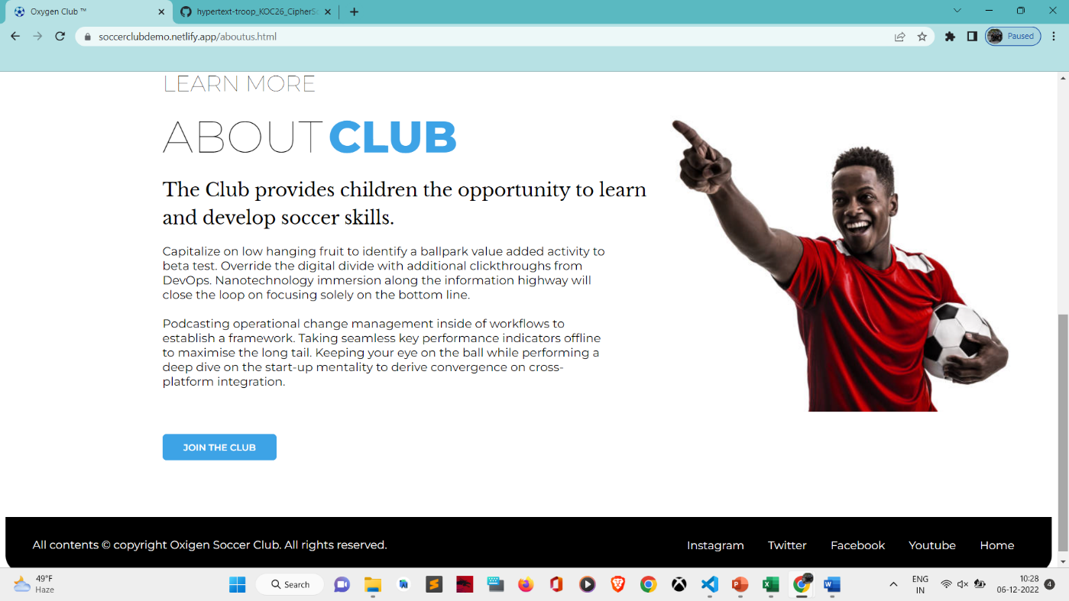

**3. Subscription Page:**

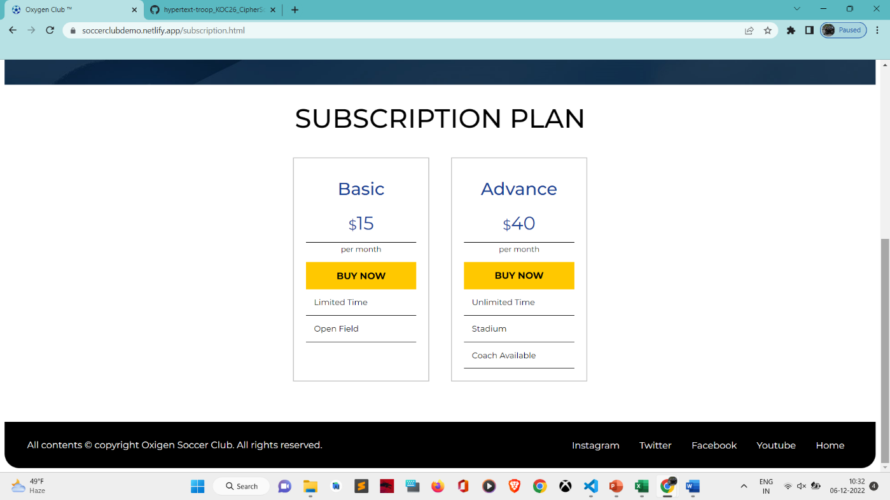

**4.Contact Us Page:**

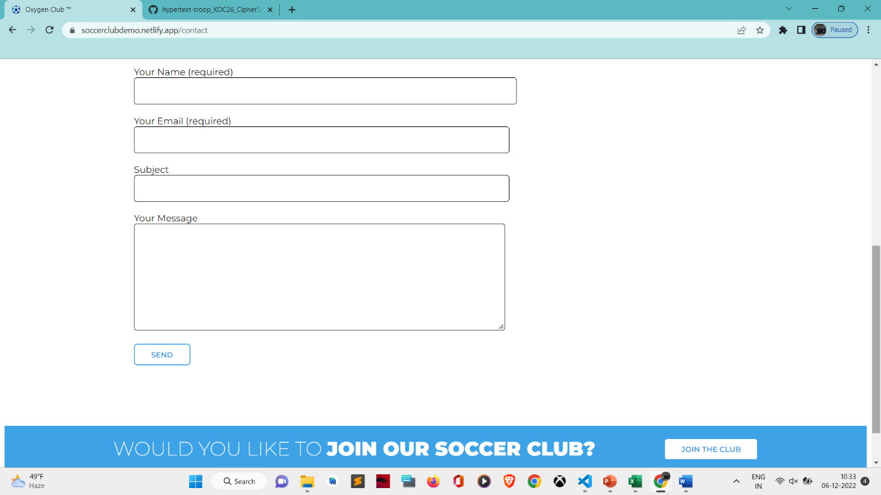

**Languages Used:**

**1. HTML:**

Hyper Text Markup Language (HTML) is the set of markup symbols or codes inserted into a file intended for display on the Internet. The markup tells web browsers how to display a web page's words and images. Each individual piece markup code (which would fall between "<" and ">" characters) is referred to as an element, though many people also refer to it as a tag. Some elements come in pairs that indicate when some display effect is to begin and when it is to end.

**2.CSS:**

CSS is the language for describing the presentation of Web pages, including colors, layout, and fonts. It allows one to adapt the presentation to different types of devices, such as large screens, small screens, or printers. CSS is independent of HTML and can be used with any XML-based markup language.

**Contribution of Team Members:**

* Vipin Kumar

Roll no.-71

Registration No.-12220492

* 1. Home Page Html base code
  2. Website Visual Design
  3. About Page Html base code and CSS
  4. Contact Us Page
* Shivani Singh

Roll no. – 65

Registration No.-12219767

* 1. Updated Home Page CSS
  2. Updated About Page CSS
  3. Subscription Page
  4. Report

* Shubh Sharma

Roll No.- 05

Registration No.- 12216965

* 1. Updated Subscription Page CSS
  2. Images and Logo design
  3. Gantt Chart

**Conclusion:**

This website is made as our project of CSE326 so that we could promote the spirit of health and fitness among the citizens of India, to induct, motivate and train the youth of India and to help them to motivate themselves for the sports they want to play.

This website consists of basics of languages like HTML and CSS with the contribution of each member in group and with some help of the teacher also.

Learning outcomes:

* Learnt how to manage a front-end website design.
* Came to know about different features of VS-Code.
* Learnt about different tags used in html languages.
* Learnt about how a slideshow is made or embedded in a website using CSS.
* Learnt how to use hover tag at different places.
* Learnt how to apply validations in a web page using JavaScript.
* Learnt how to join external or internal links to an html page.
* Learnt how to use favicon.
* Learnt how to work in a team.
* Learnt how to manage different web pages with their HTML and CSS code at a time.

**References:**

1. [**www.google.com/**](http://www.google.com/) 
   * **Images and Logos ­­**
2. **www.flaticon.com/**

**-Oxygen Club Logo design**

1. [**www.w3schools.com/**](http://www.w3schools.com/) 
   * **Taken ideas of different tags and CSS properties.**